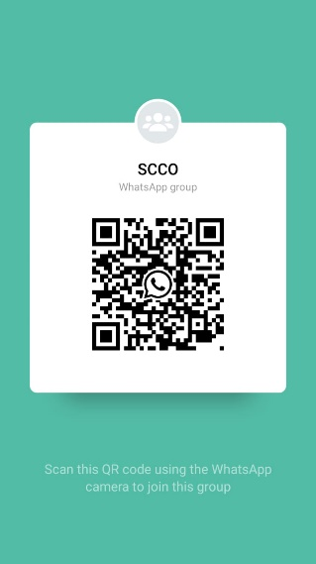
Link for registration:
https://docs.google.com/forms/d/e/1FAIpQLScYmWXLJ-ILVzmUi60CSYrYv3ZZMSkUyupgEzD0KL2GO4IS_g/viewform
Join my WhatsApp group:
https://chat.whatsapp.com/CXoSCTrZJdgB8yBEpIpxYf
Looking forward to meeting you during the webinar.

With best regards,
Organizing Committee, SCCO-2020

